

**Cecil Andrews College**

**Year 11 Physics – Evaluation and Analysis 1**

**Take-home component**

**Date Out: 17th May 2019**

**Date Due: 24th May 2019**

|  |  |
| --- | --- |
| **Take Home Component weighting:** 2% | **In-Class Component Weighting:** 6% |

***Note:*** The take home component of this assessment is the “research” section. This will be followed by the in-class validation, both are worth 8% of the semester’s grade. You are expected to create hand-written notes using the information and prompts provided in this take-home component which you will bring on Friday of Week 4 – 24th May 2019. Failure to bring the hand-written notes or to provide evidence of engagement with the take-home component will result in a ***25% penalty***. For the in-class component, you will be allowed up to three A4 pages (front and back) of notes, and this take-home handout.

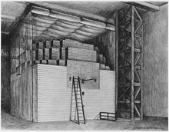**Nuclear Fission**

The 2nd of December 1942 was a crucial day in the development of nuclear technology as Enrico Fermi and his team created the first nuclear pile to go critical. As the result of research by him and many others, the age of the nuclear bomb and the nuclear reactor was born.

These two devices have changed the world, one due to its destructive power, the other as a power source to run our energy hungry world.

The link between these two devices- **Nuclear fission**.

**Your Task**

Compare and contrast (from a physics perspective) the use of nuclear fission in these two applications.

Describe also how the processes involved in the Sun compare to the other two applications.

Your research should include information on: (these are a guide only).

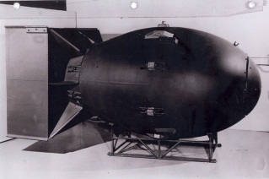

* What is nuclear fission?
* What is nuclear fusion?
* What is a chain reaction?
* What is critical mass?
* Is every material that can undergo fission, fissile?
* What is the **basic** structure of each device, the atomic bomb and the fission reactor (1)?
* What features are used to control the fission reaction in each device?
* How is the energy harnessed from each device?
* Can we classify Nuclear energy as “clean energy”?
* What are the death rates per unit energy produced for different sources of energy (wind, solar, coal-thermal, etc.)?
* What are the differences between slow moving neutrons and fast neutrons?

**The Validation**

You will be allowed to bring **HAND WRITTEN** notes into the validation exercise.

The notes will not be collected. Failure to have notes, results in a **25% penalty.**

**(1)** There are many forms of nuclear reactors. You only need to focus on the fundamental structures which are common to most.